The Miraculous Journey of Edward Tulane Comprehension Guide By Kate DiCamillo

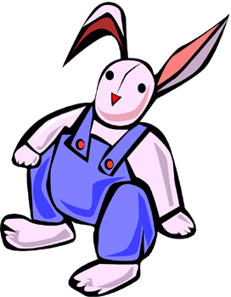
Name: _____________________ Date: ________________

Directions: Answer the following questions about the story

The Miraculous Journey of Edward Tulane. Always use complete
sentences.

Good Readers will try to find meanings from the words…

Word Study
In order to better comprehend what they are reading, good readers will try to find the meanings of the key vocabulary in the story. Please refer to the “Word Study” sheet in the back of your packet for the words. Your job will be to either use the vocabulary words in a sentence or find their meanings. Some vocabulary words may have several meanings, so make sure that your definition fits the way you think it would be used in the story.

Please remember to be neat and skip lines between each definition/sentence. Also, if there are more than 2-3 words per day, your teacher may have you work with a partner, discuss them in a group, or provide the meanings for you.

Good Readers will use context clues…

Prior to Reading

Strategy Focus: Making Predictions

Good readers will predict. Preview your book and make a prediction about what the book is about. Your prediction should be at least 2 sentences. Your prediction must include what you think the book will be about and also how you think the main character(s) will fit into the story.

Day 1 Reading: Chapters 1 & 2

Strategy Focus: Making Connections
Good readers will make connections to what they are reading to their own lives. In this story, a young girl named Abilene has a china rabbit that she cherished dearly. Do you or have you ever had a something that really meant a lot to you? Explain your connection below.

Remember, good readers will use their reading strategies…
- Describe in detail what Edward Tulane looked like.

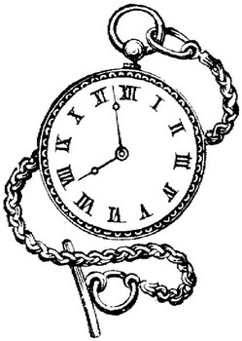
- Besides dressing Edward, what would Abilene do for Edward each morning before she went to school?

- What season do you like best? Explain why.

- What season did Edward seem to like best? Why.

- Who were the family members that lived with Edward?

- Describe Pellegrina.

- Describe below what Rosie, the neighbor’s boxer dog, did when he came uninvited in the Tulane house one day.

- Edward did not like to be called a “bunny”. In fact he found it “derogatory” in the extreme. What did he mean by this?

- Why was Edward so annoyed at the maid at the end of chapter 2?

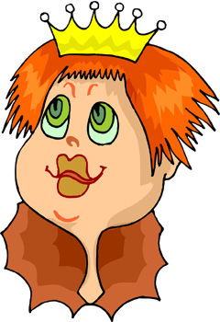
Day 2 Reading: Chapters 3-5

Strategy Focus: Sequencing
Good readers will try to organize events in order to make sense out of what they are reading. Put Pellegrina’s princess story in order. Place a number 1 in the blank for the event that happened first.
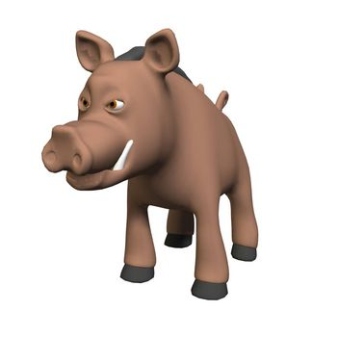
_____ | “The king, the princess’s father, said that the princess must marry.”
_____ | “The beautiful princess was changed into a warthog.”
_____ | “The princess got lost in the woods and wandered for many days until she finally came to a little hut.”
_____ | Abilene picked up Edward and sat him next to her on her bed.
_____ | “The princess told the witch that she loved no one. The witch was disappointed and raised up her hand and said ‘Farthfigery’”.
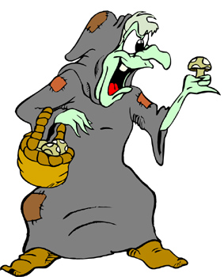  _____ | “The witch asked the princess to tell her the name of the one that she loved.”
_____ | “There once was a beautiful princess who loved no one.”
_____ | “The kings’ men were looking for the princess and when they came up to the warthog, they shot it immediately. Then they took it back to the castle, slit it open, and found a ring of pure gold.”
_____ | “A prince came and gave the princess a gold ring and told her he loved her. The princess swallowed the ring and said, ‘That is what I think of love.” Then she went deep into the forest.”
_____ | “The princess knocked on the hut. Then a voice answered, ‘Enter if you must’. She entered and saw a witch sitting at the table counting gold.”

- After the story, Abilene was disappointed because no one in the story lived happily ever after. Then Pellegrina’s response was, “How can a story end happily if there is no love?” What do you think she meant by this.

- Why do you think Edward seemed to like looking at the stars?

- Describe what happened to Edward while he and the Tulane family were aboard the Queen Mary on their way to England?
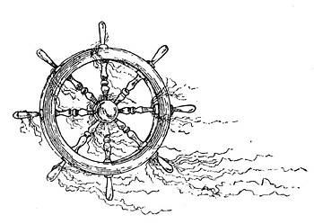

Remember, good readers will use clues to help comprehend…
Day 3 Reading: Chapters 6-8
- As Edward was falling to the ocean, he noticed Abilene holding something. What did Edward think that he saw Abilene holding?

- What emotion did Edward feel when he fell to the bottom of the ocean floor, face down with his head in the muck?

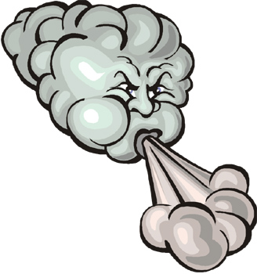
- What happened on the two hundred and ninety-seventh day that Edward was on the ocean floor?

- What emotion did Edward feel when the “old man” gave him a ride?

- Lawrence gave Edward to his wife, Nellie. Nellie said to Lawrence, “Oh, Lawrence, you brung me a rabbit.” And then she gave Edward a name. What name did Nellie give to Edward?

Strategy Focus: Making Inferences
Good readers will use the clues that the author uses to draw their own conclusions about what the author is trying to say. What clues does the author use that may tell you that Lawrence is a nice person but may not be too educated?

Day 4 Reading: Chapters 9-11

Strategy Focus: Visualizing
Good readers will draw pictures in their heads as they read. In the box below, draw and color a picture Edward Tulane in one of the outfits that Nellie made for him.



- Why did Edward “wonder if some of the muck from the ocean floor had gotten inside his china head and damaged him somehow”?

- Every night after dinner, Lawrence would go out and get some fresh air and put “Susanna” on his shoulder, light his pipe, and if the night was clear he said the names of the constellations one at a time. Connect at least 5 of the stars below to make your own constellation. Then give a name to your constellation.

Good readers will look back to the book to find answers to questions…
- Do you like Lolly? Why or why not.

- What did Lolly do with Edward? Why do you think that she did that?

- Describe Ernest.



- What happened on Edward’s one hundred and eightieth day at the dump?

Day 5 Reading: Chapters 12-14

- Why was Edward exhilarated while being held in the slobbery mouth of a dog (Lucy) being chased by a mad man (Ernest- King of the dump)?

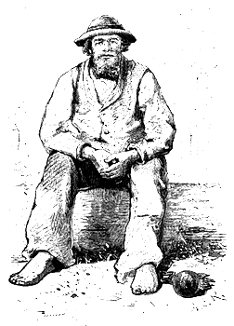
- Why did the man mean when he said to Lucy, “Rabbit pie is a true delight, one of the pleasures of our existence- but the best chef in the world would be hard-pressed to make him into a pie”?

- Who was Bull and what was the name he gave Edward?

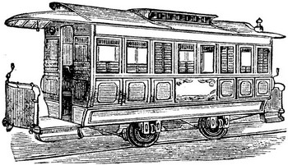
- What did Edward do while Bull and Lucy slept?

- What feeling did Edward finally feel?

- How did Bull dress Edward and what did he say to Edward when he was done?

- What happened to Edward at the end of Chapter Fourteen?

- What emotion did Edward want to show when he found himself looking up at the constellations, listening to the cricket?

Strategy Focus: Making Connections
Good readers will make connections to what they are reading to their own lives. In this story, Bull is a hobo who travels by train. If you were Bull, what would be the name of your train? Write this name on the car below. Color the train if you have time.

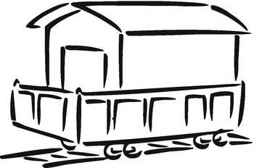
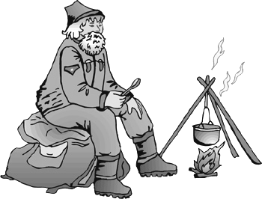

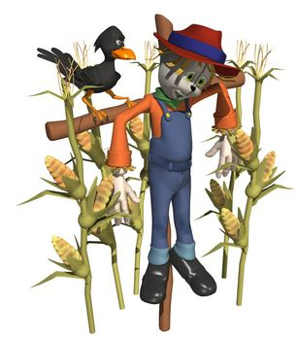
Make a list in your head of all of the emotions Edward has faced…
Day 6 Reading: Chapters 15 & 16

- What did the old woman decide to do with Edward?

- The crows were insistent. They flew around Edward (Clyde) and picked at his clothes. He even compared one crow to Pellegrina. Why do you think he was “done with caring”?
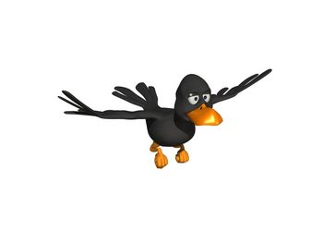

- Describe the conversation that Edward had with the stars.

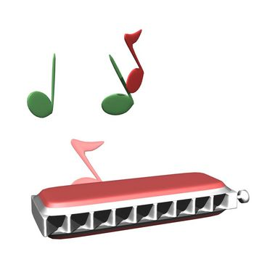
- What caused Edward to have the feeling of joy?

Strategy Focus: Making Connections
Good readers will make connections to what they are reading to their own lives. When Edward is hanging like a scarecrow and watching the crows fly around him, he wishes he could fly. He thinks if he could fly, he wouldn’t have fallen in the ocean. Explain in 1-2 sentences how your life would change if you had wings and could fly.

Day 7 Reading: Chapters 17 & 18

- Bryce used the word “he” many times in his story about his sister Sarah Ruth. Bryce told Edward that he (not Bryce) broke Sarah Ruth’s doll when he was drunk. He won’t buy Sarah Ruth nothing. He says that she don’t need nothing. He says she don’t need nothing because she ain’t gonna live. Who is Bryce referring to?

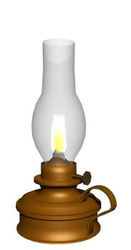

- Describe the house that Sarah Ruth and Bryce lived in.

- Describe the feeling Edward had when Bryce handed him to Sarah Ruth.

Strategy Focus: Making Connections
Good readers will make connections to what they are reading to their own lives. Bryce seems to calm his sister by playing the harmonica. What type of instrument or music would calm you if you were sick? Explain in detail.

What kind of music do you like to listen to?
Day 8 Reading: Chapters 19-21

- Describe Sarah Ruth’s father.

- What did Bryce do to Edward with the twine?

- What do you think about Bryce? Circle four adjectives below that would describe him.

Nice | Mean | Caring | Musical
Not friendly | Selfish | Calm | Hyper
Athletic | Funny | Sneaky | Honorable

Strategy Focus: Making Connections

Good readers will make connections to what they are reading to their own lives. When Bryce held Sarah Ruth and Sarah Ruth held Edward, Bryce said, “You got to look for the falling stars. Them the ones with magic.” If you saw a falling star, what would you wish for?

Strategy Focus: Making Inferences
Good readers will use the clues that the author uses to draw their own conclusions about what the author is trying to say. What clues from the story would tell you what Edward wished when he saw the falling star?

- Describe what happened to Sarah Ruth.

- Do you think Bryce’s father loved Sarah Ruth? Explain why or why not.

- Why do you think Bryce wants to go to Memphis?

Good readers will make connections to their reading…

Strategy Focus: Making Connections
Good readers will make connections to what they are reading to their own lives. Bryce brought Edward to Memphis and played the harmonica on the streets as he made Edward dance. If you could perform something on the streets for some extra money, what might you do?


- When Neal found out that Bryce could not pay for the meal at the diner, he said, “You ordered it. I cooked it. Marlene served it. You ate it… Now I want my money.” What was Bryce’s response to Neal?

- What did Neal do to Edward?

Strategy Focus: Characterization
Good readers will understand the characters in the story. At Neal’s Diner, Bryce ordered some pancakes, eggs, a big old steak, some toast, and some coffee. If you were Edward, what would be the name of your restaurant? Make a cover the menu in the space below. Then in the space below the menu, describe what your “Special” would be.

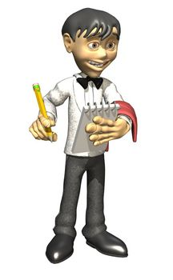

“Special of the day”

Good readers will make predictions…
Day 9 Reading: Chapters 22 & 23

- Edward’s world went black. Describe what Edward was thinking at the beginning of Chapter 22.

Strategy Focus: Making Connections
Lucius Clarke talks to Edward as if he were real. In fact, everyone in the story seems to talk to Edward as if he were real. Have you ever talked to a pet, a stuffed animal, or anything as if it were real? Explain.

- What were the two options that Lucius Clarke gave Bryce when Bryce told him that he could not pay for the repair work on Edward?

- Look at the cover of the book. What part of the story is this from? Who will open the door?

Strategy Focus: Making Predictions

Good readers will predict. What do you think will happen to Edward now? Will Edward find love again?

Day 10 Reading: Chapters 24 & 25
- When Bryce came in the shop Lucius told Bryce, “Young man I am afraid that we made a deal.” Why do you think Lucius act this way to Bryce? Do you Lucius was nice?

- Edward was not alone in the doll shop. In fact Lucius Clarke’s shop was filled with dolls- lady dolls and baby dolls, dolls with eyes that opened and closed and dolls with painted-on eyes, dolls dressed as queens and dolls wearing sailor suits. But Edward never cared for dolls. He found them annoying, self-centered, twittery, and vain. Fill in the table below about what Edward thought about dolls.

Edward’s  Word | Definition  (Look up definitions of the words) | Do you agree with Edward’s Description about dolls?
Annoying |  | ___ Yes | ___ No
Self-centered |  | ___ Yes | ___ No
Twittery |  | ___ Yes | ___ No
Vain |  | ___ Yes | ___ No

Strategy Focus: Making Connections


Edward told the doll that he has already been loved. He told her, “I have been loved by a girl named Abilene. I have been loved by a fisherman and his wife and a hobo and his dog. I have been loved by a boy who played the harmonica and by a girl who died. Don’t talk to me about love. I have known love.” In the space below, write three sentences of about yourself being loved. Your sentences must include the name of the person and what that person does. An example is provided.

Example: I have been loved by a brother who loves sports.

I have been loved by…

I have been loved by…

I have been loved by…

Day 11 Reading: Chapters 26 & 27

- The old doll that was placed next to Edward was made of china and like Edward, had also been broken into pieces and repaired. Out of all of the other characters in the story, which one could have owned her? Bull? Bryce? Abilene? Pellegrina?...

- What did the old doll mean when she told Edward to “open your heart… someone will come. Someone will come for you. But first you must open your heart.” Did Edward open his heart?

Strategy Focus: Making Inferences
Good readers will use the clues that the author uses to draw their own conclusions about what the author is trying to say. “Someone will come… Someone will come… someone will come” is what Edward repeated to himself year after year. Then one day, a little girl grabbed him and cradled Edward in her arms. The story didn’t really tell you, but who was this girl?

- In your opinion, did Edward find love?

On-Going Activity
Mood, Emotions

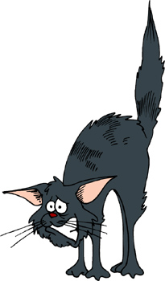

Directions: Throughout this story there were many emotions that Edward encountered. Fill in the chart next to each emotion and give an example of how Edward displayed that emotion. If you are unable to find an emotion for at least 5 of the choices below, write your own emotion from the story.



Fear
Loneliness
Hope
Love
Sadness
Excitement
Happiness

On-Going Activity
Setting
As you read the story, write down details about the setting in the chart below. Include the page numbers where you found the information.

Setting  (page # or chapter) | Where  (locations) | Main Event  (describe an event that  happened in this setting)
Example of a Setting
P. 5 | Tulane Home on Egypt Street | Edward waited for Abilene to  come home from school.

The Miraculous Journey of Edward Tulane
End of Novel Project Choices

The following choices will be due at the end of the novel. You will
most likely have some time in class to complete this, but you may
have to do some at home.

Names for Edward
Edward had many names throughout this novel. You are asked to come up with 10 other names for Edward. In addition to the names, you must also include an explanation of how the name has to do with something that happened in the story.
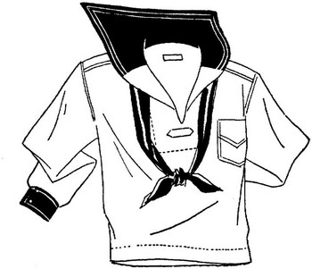

Outfits
Edward had several unique outfits throughout the story. You are asked
to design at least three outfits for Edward. You must draw a colorful
picture of the outfits and provide a brief explanation about where in the
book Edward would wear each outfit. For some extra credit, you could
actually make one of the outfits out of real cloth!

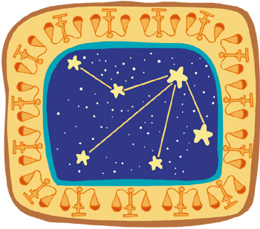
Constellations

Throughout the story, constellations and stars are mentioned often. You are asked to research and draw five constellations. You must draw each constellation and then provide some history or other interesting information.

Create a Song
You are asked to create a song that Bull would have sung about
Edward Tulane. Your song must include events from the story.
It must include at least 3 verses (at least 4 lines long) and a chorus
(at least 5 lines long).

Collage
Choose a character from The Miraculous Journey of Edward Tulane that you find most interesting. Create a collage that is about this character. On the back of the collage, write a paragraph (5 sentences) about why you chose the pictures that you did.

IPod Touch
Design your own IPod Touch. Your IPod Touch should include ten “Apps”. You will need to create a colorful IPod. You will also need to write two sentences for each application explaining what the application is and how it relates to the story. You will need to get the IPod sheet from your teacher.

IPod Touch

The Miraculous Journey of Edward Tulane
Good readers will try to find the meanings of key words…
Word Study

Reading Strategy Focus: Word Study
In order to better comprehend what they are reading, good readers will try to find the
meanings of the key vocabulary in the story. Sometimes they may ask someone what a
word means or use context clues to figure out the meaning. Good readers will also look
up the definition.

Your Job: Your job will be to either use the vocabulary words below in a sentence or find the meanings of the words. Some vocabulary words may have several meanings, so make sure that your definition fits the way you think it would be used in the story. Please skip lines between each definition. This work must be done neatly or you will do it over. If there are more than 2-3 words per day, your teacher may have you work with a partner, discuss them in a group, or provide the meanings for you.

Day 1 Reading  Chapter 1  Jaunty p. 5  Unsavory p. 6  Array p. 6  Condescending p. 9  Commissioned p. 9  Chapter 2  Domestic p. 15  Inexplicably p. 15  Indignities p. 16  Diligence p. 16  Derogatory p. 16  Demented p. 18  Day 2 Reading  Chapter 3  Excruciatingly p. 23  Jovially p. 24  Chapter 4  Consequences p. 32  Grotesque p. 35  Chapter 5  Disregarding p. 42  Billowed p. 42  Triumphantly p. 44  Day 3 Reading  Chapter 6  Blithely p. 49  Chapter 7  Descent p.55  Umbrage p. 58  Chapter 8  Callused p. 61 | Day 4 Reading  Chapter 9  Elegance p. 68  Kneading p. 68  Pneumonia p. 69  Chapter 10  Abiding p. 75  Skivvy p. 76  Bewitched p. 77  Tremulous p. 78  Chapter 11  Rancid p. 81  Cackling p. 83  Day 5 Reading  Chapter 12  Ferocity p. 87  Exhilarated p. 88  Chapter 13  Consumption p. 95  Resonated p. 96  Subsequent p. 97  Chapter 14  Regretted p. 104  Anguished p. 106  Day 6 Reading  Chapter 15  Despair p. 110  Ceasing p. 112  Mocked p. 112  Chapter 16  Relief p. 120 | Day 7 Reading  Chapter 17  Loathed p. 124  Kerosene p. 124  Mournful p. 126  Sensation p. 128  Chapter 18  Particularly p. 135  Intrusive p. 135  Tentative p. 135  Day 8 Reading  Chapter 19  Unraveled p. 141  Muttering p. 144  Chapter 20  Hobbled p. 150  Chapter 21  Reckon p. 155  Day 9 Reading  Chapter 22  Pang p. 163  Chapter 23  Exceedingly p. 167  Surpassingly p. 167  Pun p. 168  Mender p. 168  Oblivion p. 168  Investment p. 171 | Day 10 Reading  Chapter 24  No words  Chapter 25  Twittery p. 181  Impassioned p. 183  Immobile p. 184  Day 11 Reading  Chapter 26  Acquaintance p. 187  Expectancy p. 189  Chapter 27  Outrageous p. 195

End of Story Comprehension Check

Name ___________________________ Date _________________

Project Choice: ________________________________

Student Evaluation

- On a scale of 0-5, I would rate this book a ______.

- My favorite part of this books was:

- On a scale of 0-5, I would rate my effort on the final project a ______.

- On a scale of 0-5, I would rate the neatness of my final project a _____.

- I think my overall grade on the final project would be a ______.

Teacher Evaluation

 | 5 Points | 4-3 | 2-1
Content | Wow! Above and Beyond expectation! Your project really shows that you understood the story! | Shows a lot of comprehension of story through activity chosen (main characters, setting, main events, problem, and solution). | Shows some or minimal  comprehension of story through activity chosen.
Effort | Wow! Above and beyond expectations! Your work was very neat and it seems as though you put your best effort toward this! | Worked hard, was not easily distracted. Seems like you put some effort into your final project. | Worked hard, was sometimes distracted. Maybe could have used more effort on final project.

Grade: ________

Guided Reading Packet Rubric

Reader’s Name: __________________________ Date: ______________

 | Level 1 | Level 2 | Level 3-4 | Above and Beyond
Making Connections  Text-to-Text  Text-to-Self  Text-to-World | Reader made no connections between text and self/text/or world. | Reader made simple  connections but did not  explain them all in detail. | Reader made connections and based them on background knowledge and/or experiences. Reader also had clear explanations on most connections. | With all connections, reader explained in detail how their background experiences aided in the comprehension of text.
Vocabulary  Word Recognition | Reader did not identify any vocabulary words. Reader seems to have difficulty understanding meaning of many words in the book. | Reader identified some unknown words but seems to have some difficulty understanding meaning of some words  in the book. | Reader identified many unknown words and was able to identify the meaning of most words discussed. | Reader identified the majority words that he/she did not understand. Reader seemed to gain a vast amount of knowledge through the word study and was also willing to share that with the group.
Comprehension  Summarizing | Reader showed little or no awareness of what the story was about through the assigned comprehension questions and discussions. | Reader included some main details in the comprehension questions and discussions but left out some very important events. | Reader retold the story using main ideas and supporting details in the comprehension questions and discussions. | Reader retold the story effectively and efficiently and was always willing to share  with the group.
Predicting  Making  Inferences | Reader’s predictions seemed to lack any connection to what previously happened in the story or what could happen in the story. | Reader attempted to make predictions or draw conclusions but did not use the text to defend the statement. | Reader drew conclusions and/or made predictions based on what could happen in the story. The reader also defended these predictions by using information found in the story. | Reader’s predictions, interpretations, and/or conclusions  about the story included connections between the text and the reader's background knowledge, ideas, and/or beliefs.
Packet | Reader’s packet was incomplete. Packet was messy. | Reader’s packet was somewhat complete. There were parts missing and/or questions were not fully answered. | Reader’s packet was complete. All questions were answered accurately and complete. Packet was neat. | Reader’s packet was complete. All answers were complete and detailed. Packet is neat and easy to read. Most spelling was accurate.

A= 20-18 B= 17-16 C= 15-14 D= 13-12

Total Points ____ Student grade: _______

Guided Reading Assessment Grid
Directions: The following tables can be used as an assessment tool for when discussing books with the group at the table. You can refer to the back for more detailed rubric.

Book Title: _________________________________ Date: ____________________

Student: |  |  |  |  |  |  | Student:
Connections |  |  |  |  |  |  | Connections
Vocabulary |  |  |  |  |  |  | Vocabulary
Comprehension |  |  |  |  |  |  | Comprehension
Predicting |  |  |  |  |  |  | Predicting
Rating Scale 1-5 (please refer to back for details) |  |  |  |  |  |  | Rating Scale 1-5 (please refer to back for details)

Student: |  |  |  |  |  |  | Student:
Connections |  |  |  |  |  |  | Connections
Vocabulary |  |  |  |  |  |  | Vocabulary
Comprehension |  |  |  |  |  |  | Comprehension
Predicting |  |  |  |  |  |  | Predicting
Rating Scale 1-5 (please refer to back for details) |  |  |  |  |  |  | Rating Scale 1-5 (please refer to back for details)

Student: |  |  |  |  |  |  | Student:
Connections |  |  |  |  |  |  | Connections
Vocabulary |  |  |  |  |  |  | Vocabulary
Comprehension |  |  |  |  |  |  | Comprehension
Predicting |  |  |  |  |  |  | Predicting
Rating Scale 1-5 (please refer to back for details) |  |  |  |  |  |  | Rating Scale 1-5 (please refer to back for details)

Student: |  |  |  |  |  |  | Student:
Connections |  |  |  |  |  |  | Connections
Vocabulary |  |  |  |  |  |  | Vocabulary
Comprehension |  |  |  |  |  |  | Comprehension
Predicting |  |  |  |  |  |  | Predicting
Rating Scale 1-5 (please refer to back for details) |  |  |  |  |  |  | Rating Scale 1-5 (please refer to back for details)

Guided Reading Rubric
Back Page
 | Level 1 | Level 2 | Level 3-4 | Above and Beyond
Making Connections  Text-to-Text  Text-to-Self  Text-to-World | Reader made no connections between text and self/text/or world. | Reader made simple  connections but did not explain them all in detail. | Reader made connections and based them on background knowledge and/or experiences. Reader also had clear explanations on most connections. | With all connections, reader explained in detail how their background experiences aided in the comprehension of text.
Vocabulary  Word Recognition | Reader did not identify any vocabulary words. Reader seems to have difficulty understanding meaning of many words in the book. | Reader identified some unknown words but seems to have some difficulty understanding meaning of some words  in the book. | Reader identified many unknown words and was able to identify the meaning of most words discussed. | Reader identified the majority words that he/she did not understand. Reader seemed to gain a vast amount of knowledge through the word study and was also willing to share that with the group.
Comprehension  Summarizing | Reader showed little or no awareness of what the story was about through the assigned comprehension questions and discussions. | Reader included some main details in the comprehension questions and discussions but left out some very important events. | Reader retold the story using main ideas and supporting details in the comprehension questions and discussions. | Reader retold the story effectively and efficiently and was always willing to share with the group.
Predicting  Making  Inferences | Reader’s predictions seemed to lack any connection to what previously happened in the story or what could happen in the story. | Reader attempted to make predictions or draw conclusions but did not use the text to defend the statement. | Reader drew conclusions and/or made predictions based on what could happen in the story. The reader also defended these predictions by using information found in the story. | Reader’s predictions, interpretations, and/or conclusions about the story included connections between the text and the reader's background knowledge, ideas, and/or beliefs.

The Miraculous Journey of Edward Tulane Comprehension Guide By Kate DiCamillo

Name: _____________________ Date: ________________

Directions: Answer the following questions about the story
The Miraculous Journey of Edward Tulane. Always use complete
sentences.

Good Readers will try to find meanings from the words…

Word Study
In order to better comprehend what they are reading, good readers will try to find the meanings of the key vocabulary in the story. Please refer to the “Word Study” sheet in the back of your packet for the words. Your job will be to either use the vocabulary words in a sentence or find their meanings. Some vocabulary words may have several meanings, so make sure that your definition fits the way you think it would be used in the story.

Please remember to be neat and skip lines between each definition/sentence. Also, if there are more than 2-3 words per day, your teacher may have you work with a partner, discuss them in a group, or provide the meanings for you.

Good Readers will use context clues…

Prior to Reading

Strategy Focus: Making Predictions

Good readers will predict. Preview your book and make a prediction about what the book is about. Your prediction should be at least 2 sentences. Your prediction must include what you think the book will be about and also how you think the main character(s) will fit into the story.

Answers will vary.

Day 1 Reading: Chapters 1 & 2

Strategy Focus: Making Connections
Good readers will make connections to what they are reading to their own lives. In this story, a young girl named Abilene has a china rabbit that she cherished dearly. Do you or have you ever had a something that really meant a lot to you? Explain your connection below.

Answers will vary.

Remember, good readers will use their reading strategies…
- Describe in detail what Edward Tulane looked like.

p. 5-6 He was made almost entirely of china. He had china paws, arms, legs, head, body, and nose. His ears were made of real rabbit fur with bendable wires in them. His tail was made of real rabbit fur also. His eyes were blue. Edward was almost three feet tall. His whiskers were from something but not sure of origin.

- Besides dressing Edward, what would Abilene do for Edward each morning before she went to school?

p. 7 Abilene would wind his gold pocket watch for him and tell him, “When the big hand is on the twelve and the little hand is on the three, I come home to you.” Then she would place Edward on a chair in the dining room so that he could see the path that led up to the Tulane front door.

- What season do you like best? Explain why.

Answers will vary.

- What season did Edward seem to like best? Why.

p. 8 Edward preferred winter because the sun set early and he could see his own reflection in the window.

- Who were the family members that lived with Edward?

p. 8 Abilene Tulane; her mother and father; and Abilene’s grandmother named Pellegrina.

- Describe Pellegrina.

p. 9 She was old. She had a large, sharp nose and bright, black eyes. Pellegrina had Edward made in France and also ordered all of his suits, his fine leather shoes, and his pocket watch. She tucked Abilene and Edward in at night. She would also tell stories at night.

- Describe below what Rosie, the neighbor’s boxer dog, did when he came uninvited in the Tulane house one day.

p. 15 Rosie went to the bathroom on the white dining room tablecloth, sniffed Edward, and then shook Edward vigorously in his mouth.

- Edward did not like to be called a “bunny”. In fact he found it “derogatory” in the extreme. What did he mean by this?

p. 16 Edward seemed a bit spoiled at first. He thought being called a bunny was an insult.

- Why was Edward so annoyed at the maid at the end of chapter 2?

P. 18-19 The maid put Edward in an uncomfortable position in Abilene’s room with all the rest of the dolls. He was annoyed because she treated him as if he were a serving bowl or teapot.

Day 2 Reading: Chapters 3-5

Strategy Focus: Sequencing
Good readers will try to organize events in order to make sense out of what they are reading. Put Pellegrina’s princess story in order. Place a number 1 in the blank for the event that happened first.
___3__ | “The king, the princess’s father, said that the princess must marry.”
___9__ | “The beautiful princess was changed into a warthog.”
___5__ | “The princess got lost in the woods and wandered for many days until she finally came to a little hut.”
___1__ | Abilene picked up Edward and sat him next to her on her bed.
___8__ | “The princess told the witch that she loved no one. The witch was disappointed and raised up her hand and said ‘Farthfigery’”.
___7__ | “The witch asked the princess to tell her the name of the one that she loved.”
___2__ | “There once was a beautiful princess who loved no one.”
___10__ | “The kings’ men were looking for the princess and when they came up to the warthog, they shot it immediately. Then they took it back to the castle, slit it open, and found a ring of pure gold.”
___4__ | “A prince came and gave the princess a gold ring and told her he loved her. The princess swallowed the ring and said, ‘That is what I think of love.” Then she went deep into the forest.”
___6__ | “The princess knocked on the hut. Then a voice answered, ‘Enter if you must’. She entered and saw a witch sitting at the table counting gold.”

- After the story, Abilene was disappointed because no one in the story lived happily ever after. Then Pellegrina’s response was, “How can a story end happily if there is no love?” What do you think she meant by this.

p. 34 Answers will vary.

- Why do you think Edward seemed to like looking at the stars?


p. 35 The stars seemed to comfort Edward. Pellegrina’s also described the princess as so beautiful that she shone like the stars on a moonless night.

- Describe what happened to Edward while he and the Tulane family were aboard the Queen Mary on their way to England?

P. 41-44 Two brothers (Amos and Martin) grabbed Edward off the deck and ripped off his clothes. Edward’s pocket watch fell to the deck of the ship. Then Martin threw Edward and he sailed naked through the air. Amos caught him. Abilene tackled Amos and causing Edward to go overboard.

Remember, good readers will use clues to help comprehend…
Day 3 Reading: Chapters 6-8
- As Edward was falling to the ocean, he noticed Abilene holding something. What did Edward think that he saw Abilene holding?

p. 48 Abilene was standing on the deck of the ship, holding on to the railing with one hand. In the other hand, at first thought it was a ball of fire, but it wasn’t- it was his gold pocket watch.

- What emotion did Edward feel when he fell to the bottom of the ocean floor, face down with his head in the muck?

p. 49 Edward felt afraid.

- What happened on the two hundred and ninety-seventh day that Edward was on the ocean floor?

p. 55 A powerful storm came. It was so powerful that it lifted Edward off the ocean floor and put him into a spin. The storm flung him out of the sea and back down into the sea. Then he began his slow descent down until the wide net of a fisherman reached out and grabbed him.

- What emotion did Edward feel when the “old man” gave him a ride?

p. 58 Edward felt happy.

- Lawrence gave Edward to his wife, Nellie. Nellie said to Lawrence, “Oh, Lawrence, you brung me a rabbit.” And then she gave Edward a name. What name did Nellie give to Edward?

p. 64 Nellie decided to call Edward Susanna.

Strategy Focus: Making Inferences
Good readers will use the clues that the author uses to draw their own conclusions about what the author is trying to say. What clues does the author use that may tell you that Lawrence is a nice person but may not be too educated?

Possible answers may include that he is taking care of Edward and the way that he talks to other people. The way he talks (p. 62) may tell a person that he may not be too educated.

Day 4 Reading: Chapters 9-11

Strategy Focus: Visualizing
Good readers will draw pictures in their heads as they read. In the box below, draw and color a picture Edward Tulane in one of the outfits that Nellie made for him.
Answers will vary.

- Why did Edward “wonder if some of the muck from the ocean floor had gotten inside his china head and damaged him somehow”?

p. 69 He wondered this because he found himself listening to every word of Nellie’s stories because they struck him as the most important thing in the world. Also, Edward liked to only think of himself at times.

- Every night after dinner, Lawrence would go out and get some fresh air and put “Susanna” on his shoulder, light his pipe, and if the night was clear he said the names of the constellations one at a time. Connect at least 5 of the stars below to make your own constellation. Then give a name to your constellation.

Good readers will look back to the book to find answers to questions…
- Do you like Lolly? Why or why not.

Answers will vary, but Lolly seems like a real hard person to get along with. Lolly is the daughter of Lawrence and Nellie.

- What did Lolly do with Edward? Why do you think that she did that?

p. 78 Lolly shoved Edward face-down in the garbage can. Then she took the garbage to the dump. Answers will vary for the second part.

- Describe Ernest.
P. 81 Ernest was a short man who crowed loudly and shouted while Edward was in the dump, “Who am I? I’m Ernest, Ernest who is the king of the world.

- What happened on Edward’s one hundred and eightieth day at the dump?

p. 84 The garbage around Edward shifted and he heard the sniffing and panting of a dog. Then, suddenly, the light shone on Edward’s face.

Day 5 Reading: Chapters 12-14

- Why was Edward exhilarated while being held in the slobbery mouth of a dog (Lucy) being chased by a mad man (Ernest- King of the dump)?

P. 88 Edward was happy because he was not in the dump anymore.

- Why did the man mean when he said to Lucy, “Rabbit pie is a true delight, one of the pleasures of our existence- but the best chef in the world would be hard-pressed to make him into a pie”?

P. 89 Because he knew Edward was made of china.

- Who was Bull and what was the name he gave Edward?

p. 90-91 Bull, a hobo, had a dog named Lucy and gave Edward
the name Malone.

- What did Edward do while Bull and Lucy slept?

p. 96 Edward felt a deep tenderness for Lucy. With his eyes open,
Edward stared at the constellations and said their names. He even
thought of the people who loved him. He started with Abilene, then
went on to Lawrence and Nellie and from there to Bull and Lucy.

- What feeling did Edward finally feel?

p. 96 Edward thought that he was not like the princess and that he knew about love.

- How did Bull dress Edward and what did he say to Edward when he was done?

p. 97-98 Bull thought Edward stuck out like a sore thumb with his dress. So he took his own knit stocking hat and cut a big hole in the top of it and two small holes on the side and then took off Edward’s dress. Bull cut up some handkerchiefs for pants. He told Edward, “Now you have the proper outlaw look. Now you look like a rabbit on the run.”

- What happened to Edward at the end of Chapter Fourteen?

p.104-106 A man from the train company found Bull, Lucy, and Edward on the train and told them that things are out of control and that he didn’t want bums riding for free. He also said, “No free rides for rabbits.” He kicked Edward off the train and sent him flying through the spring air.

- What emotion did Edward want to show when he found himself looking up at the constellations, listening to the cricket?

p. 106 Edward wanted to cry. He felt sad. He wondered to himself how many times to he would have to leave without saying goodbye?

Strategy Focus: Making Connections
Good readers will make connections to what they are reading to their own lives. In this story, Bull is a hobo who travels by train. If you were Bull, what would be the name of your train? Write this name on the car below. Color the train if you have time.
Answers will vary.

Make a list in your head of all of the emotions Edward has faced…
Day 6 Reading: Chapters 15 & 16

- What did the old woman decide to do with Edward?

p. 110 She hung him from a pole in her vegetable garden like a scarecrow.
She nailed his ears to the wooden pole and spread his arms out as if he
were flying and attached his paws to the pole by wrapping pieces of wire
around them.

- The crows were insistent. They flew around Edward (Clyde) and picked at his clothes. He even compared one crow to Pellegrina. Why do you think he was “done with caring”?

p. 112 Answers may vary but he may have been done with caring because when he started to have feelings towards someone, he would leave.

- Describe the conversation that Edward had with the stars.

p. 113 For the first time, Edward found no comfort in the night sky. The stars seemed to say to Edward, “You are down there alone. We are up her, in our constellations, together.” Then Edward told them, “I have been loved before.” Then the stars responded by saying, “So, what difference does that make when you are alone now?”
- What caused Edward to have the feeling of joy?

p. 120 Bryce (the boy who helped out the old woman) came back playing a
harmonica and removed him from the post. When Edward fell forward
into Bryce’s arms, he felt a rush of relief, and the feeling of relief was
followed by joy.

Strategy Focus: Making Connections
Good readers will make connections to what they are reading to their own lives. When Edward is hanging like a scarecrow and watching the crows fly around him, he wishes he could fly. He thinks if he could fly, he wouldn’t have fallen in the ocean. Explain in 1-2 sentences how your life would change if you had wings and could fly.

Answers will vary.

Day 7 Reading: Chapters 17 & 18

- Bryce used the word “he” many times in his story about his sister Sarah Ruth. Bryce told Edward that he (not Bryce) broke Sarah Ruth’s doll when he was drunk. He won’t buy Sarah Ruth nothing. He says that she don’t need nothing. He says she don’t need nothing because she ain’t gonna live. Who is Bryce referring to?

He is referring to his dad.

- Describe the house that Sarah Ruth and Bryce lived in.

p. 124-125 The house was small and crooked and Edward mistook it as a chicken coop. Inside, there were two beds and a kerosene lamp and not much else.

- Describe the feeling Edward had when Bryce handed him to Sarah Ruth.

p. 128 Never in his life had Edward been cradled like a baby. It was a single sensation to be held so gently and to be stared down with so much love. Edward felt his whole china body flood with warmth.

Strategy Focus: Making Connections
Good readers will make connections to what they are reading to their own lives. Bryce seems to calm his sister by playing the harmonica. What type of instrument or music would calm you if you were sick? Explain in detail.

What kind of music do you like to listen to?
Day 8 Reading: Chapters 19-21

- Describe Sarah Ruth’s father.

p. 134 Her father seems really confused. He says, “It don’t matter anyway. It don’t make no difference. None of it.” Then he told Bryce not to sass him and slapped Bryce across the face and left the house.

- What did Bryce do to Edward with the twine?

P. 135 Bryce returned to Sarah with a ball of twine. Bryce cut off lengths of twine and tied them to Edward’s arms and feet and then tied the twine to sticks of wood. Then, moving the strings with the sticks with one hand, Bryce made Edward dance and drop and sway.

- What do you think about Bryce? Circle four adjectives below that would describe him. Answers will vary.

Nice | Mean | Caring | Musical
Not friendly | Selfish | Calm | Hyper
Athletic | Funny | Sneaky | Honorable

Strategy Focus: Making Connections
Good readers will make connections to what they are reading to their own lives. When Bryce held Sarah Ruth and Sarah Ruth held Edward, Bryce said, “You got to look for the falling stars. Them the ones with magic.” If you saw a falling star, what would you wish for?

Strategy Focus: Making Inferences
Good readers will use the clues that the author uses to draw their own conclusions about what the author is trying to say. What clues from the story would tell you what Edward wished when he saw the falling star?

p. 138 Answers will vary, but Edward probably wished that Sarah Ruth would be healthy.

- Describe what happened to Sarah Ruth.

p. 141-142 One month had passed and then tow and then three. Sarah Ruth got worse. In the fifth month, she refused to eat. And in the sixth month, she began to cough up blood. Bryce rocked her back and forth, back and forth until on a bright September morning, Sarah Ruth stopped breathing.

- Do you think Bryce’s father loved Sarah Ruth? Explain why or why not.

Answers will vary.

- Why do you think Bryce wants to go to Memphis?

Answers will vary, but Bryce seemed to like to play music and Memphis is known for the music.

Good readers will make connections to their reading…

Strategy Focus: Making Connections
Good readers will make connections to what they are reading to their own lives. Bryce brought Edward to Memphis and played the harmonica on the streets as he made Edward dance. If you could perform something on the streets for some extra money, what might you do?

- When Neal found out that Bryce could not pay for the meal at the diner, he said, “You ordered it. I cooked it. Marlene served it. You ate it… Now I want my money.” What was Bryce’s response to Neal?

p. 157 Bryce looked at Neal and asked, “You ever seen a rabbit dance?”

- What did Neal do to Edward?

P. 157-158 Neal said, “This is what I feel about dancing rabbits!” and then he swung Edward by the feet causing his head to hit the edge of the counter. Edward was in pieces.

Strategy Focus: Characterization
Good readers will understand the characters in the story. At Neal’s Diner, Bryce ordered some pancakes, eggs, a big old steak, some toast, and some coffee. If you were Edward, what would be the name of your restaurant? Make a cover the menu in the space below. Then in the space below the menu, describe what your “Special” would be.
Answers will vary.

“Special of the day”

Good readers will make predictions…
Day 9 Reading: Chapters 22 & 23

- Edward’s world went black. Describe what Edward was thinking at the beginning of Chapter 22.

P. 161-163 Edward thought he was walking down the sidewalk on Egypt Street with a silk suit on. Then Lucy barked at the door and bull stood there. Then Bull swung the door open and Edward saw Abilene, Nellie, and Lawrence. Then Edward noticed wings on his back and tried to fly off of Lawrence’s shoulder up toward Sarah Ruth in the nighttime sky, but Bull held him firmly on the ground.

Strategy Focus: Making Connections
Lucius Clarke talks to Edward as if he were real. In fact, everyone in the story seems to talk to Edward as if he were real. Have you ever talked to a pet, a stuffed animal, or anything as if it were real? Explain.

- What were the two options that Lucius Clarke gave Bryce when Bryce told him that he could not pay for the repair work on Edward?

p. 169 -170 Lucius Clarke gave Bryce two options. The first being that Bryce seek assistance elsewhere. Option two was that Lucius would fix Edward to the best of his abilities and then Edward would be his to sell.

- Look at the cover of the book. What part of the story is this from? Who will open the door?

p. 167-170 This is the part of the story when Neal swung Edward and broke him. Then Edward sort of fell into a dream world. Bull would be the one to open the door.

Strategy Focus: Making Predictions

Good readers will predict. What do you think will happen to Edward now? Will Edward find love again?

Answers will vary.

Day 10 Reading: Chapters 24 & 25
- When Bryce came in the shop Lucius told Bryce, “Young man I am afraid that we made a deal.” Why do you think Lucius act this way to Bryce? Do you Lucius was nice?

Chapter 24 Answers will vary but Lucius seemed real business-like. Edward really didn’t mean too much at the time to Lucius.

- Edward was not alone in the doll shop. In fact Lucius Clarke’s shop was filled with dolls- lady dolls and baby dolls, dolls with eyes that opened and closed and dolls with painted-on eyes, dolls dressed as queens and dolls wearing sailor suits. But Edward never cared for dolls. He found them annoying, self-centered, twittery, and vain. Fill in the table below about what Edward thought about dolls.

Edward’s  Word | Definition  (Look up definitions of the words) | Do you agree with Edward’s Description about dolls?
Annoying | bothersome | ___ Yes | ___ No
Self-centered | concerned solely or chiefly with one's own interests | ___ Yes | ___ No
Twittery | Timid or fearful | ___ Yes | ___ No
Vain | excessively proud of or concerned about one's own appearance, qualities, achievements | ___ Yes | ___ No

Strategy Focus: Making Connections

Edward told the doll that he has already been loved. He told her, “I have been loved by a girl named Abilene. I have been loved by a fisherman and his wife and a hobo and his dog. I have been loved by a boy who played the harmonica and by a girl who died. Don’t talk to me about love. I have known love.” In the space below, write three sentences of about yourself being loved. Your sentences must include the name of the person and what that person does. An example is provided.
Answers will vary.
Example: I have been loved by a brother who loves sports.

I have been loved by…

I have been loved by…

I have been loved by…

Day 11 Reading: Chapters 26 & 27

- The old doll that was placed next to Edward was made of china and like Edward, had also been broken into pieces and repaired. Out of all of the other characters in the story, which one could have owned her? Bull? Bryce? Abilene? Pellegrina?...

Answers may vary, but the correct answer could be Sarah Ruth because she once had a china baby doll but the father broke her into pieces. She may be on a similar “journey” as Edward’s.

- What did the old doll mean when she told Edward to “open your heart… someone will come. Someone will come for you. But first you must open your heart.” Did Edward open his heart?

Answers may vary, but she thought that Edward didn’t have any hope, and without hope there was no love. P. 192 Edward did begin to open his heart.

Strategy Focus: Making Inferences
Good readers will use the clues that the author uses to draw their own conclusions about what the author is trying to say. “Someone will come… Someone will come… someone will come” is what Edward repeated to himself year after year. Then one day, a little girl grabbed him and cradled Edward in her arms. The story didn’t really tell you, but who was this girl?

p. 197-198 This girl was Abilene’s daughter.

- In your opinion, did Edward find love?

P. 198 Answers may vary, but he did discover that the little girl’s mother in the store was Abilene because she wore the gold pocket watch around her neck. Edward found love.

On-Going Activity
Mood, Emotions
Answers will vary
Directions: Throughout this story there were many emotions that Edward encountered. Fill in the chart next to each emotion and give an example of how Edward displayed that emotion. If you are unable to find an emotion for at least 5 of the choices below, write your own emotion from the story.

Fear
Loneliness
Hope
Love
Sadness
Excitement
Happiness

Setting
As you read the story, write down details about the setting in the chart below. Include the page numbers where you found the information.

Setting  (page # or chapter) | Where  (locations) | Main Event  (describe an event that  happened in this setting)
Example of a Setting
P. 5 | Tulane Home on Egypt Street | Edward waited for Abilene to  come home from school.
Ch. 5 | Queen Mary | Edward gets tossed overboard
Ch. 6 & 7 | Edward is at the bottom  of the ocean | Edward is there for several months
Ch. 8-9 | A fisherman (Lawrence) brings  Edward to his house. | The fisherman’s wife Nellie  names Edward Susanna.
Ch. 11 | Edward was put head-first in  the garbage by Nellie and Lawrence’s daughter, Lolly. | Edward ended up in the dump.
Ch. 13 | Edward was dug up by Lucy (dog) and brought to Bull (a hobo). | Bull and Lucy call Edward  Malone and take him on a train  ride where he is thrown off.
Ch. 14 | Edward was picked up by an old woman and called him Clyde. | The old woman hung Edward from a pole in her vegetable garden like a scarecrow.  She nailed his ears to the wooden pole and spread his arms out as if he were flying and attached his paws to the pole by wrapping pieces of wire around them.
Ch. 15 | Bryce brought Edward to his sister Sarah Ruth who was sick. | Bryce handed Edward to Sarah Ruth,  who held him like a baby. She called him Jangles. She died
Ch. 21 | Bryce brought Edward to Memphis and had Edward dance as he played the harmonica for money. | Bryce ate at Neal’s Diner but could not  pay for it. Neal swung Edward causing  him to break into pieces.
Ch. 23 | Bryce brings Edward to  Lucius Clarke’s doll shop. | Abilene discovers Edward in shop.

Wise Guys Reading Comprehension Guides
Below is a listing of reading comprehension guides that can be used in your classrooms.

Titles of Stories | Direct Web Link to Guides
The 39 Clues: The Maze of Bones by Rick Riordan (with Answer Key)  31 pages | http://www.teacherspayteachers.com/Product/39-Clues-Maze-of-Bones-Reading-Comprehension-Guide-KEY-31-pages
Al Capone Does My Shirts by Gennifer Choldenko  16 pages | http://www.teacherspayteachers.com/Product/Al-Capone-Does-My-Shirts-Reading-Comprehension-Guide-16-pages
And Then What Happened Paul Revere by Jean Fritz (with Answer Key)  11 pages | http://www.teacherspayteachers.com/Product/Paul-Revere-American-Revolution-book-by-Jean-Fritz-with-KEY-11-pages
Black Cowboy, Wild Horses by Julius Lester  6 pages | http://www.teacherspayteachers.com/Product/Black-Cowboy-Wild-Horses-Reading-Comprehension-Guide-6-pages
Bridge to Terabithia by Katherine Paterson  21 pages | http://www.teacherspayteachers.com/Product/Bridge-to-Terabithia-Reading-Comperehension-Guide-21-pages
Elena by Diane Stanley  7 pages | http://www.teacherspayteachers.com/Product/Elena-Reading-Comprehension-Packet-with-Activities-7-pages
Gentle Ben by Walt Morey (with Answer Key)  30 pages | http://www.teacherspayteachers.com/Product/Gentle-Ben-Reading-Comprehension-Guide-and-KEY-30-pages
Hatching Magic by Ann Downer  14 pages | http://www.teacherspayteachers.com/Product/Hatching-Magic-Reading-Comprehension-Guide-and-Activities-14-Pages
James and the Giant Peach by Roald Dahl (with Answer Key)  33 pages | http://www.teacherspayteachers.com/Product/James-and-the-Giant-Peach-Reading-Comprehension-Guide-KEY-33-pgs
James Forten by Walter Dean Myers (with Answer Key)  11 pages | http://www.teacherspayteachers.com/Product/James-Forten-Revolutionary-War-Novel-Packet-with-answer-key-11-pp
Katie’s Trunk by Ann Turner (with Answer Key)  9 pages | http://www.teacherspayteachers.com/Product/Katies-Trunk-Revolutionary-War-Novel-Study-with-Answer-Key-9-pp
The Lightning Thief by Rick Riordan (with Answer Key)  39 pages | http://www.teacherspayteachers.com/Product/Lightning-Thief-Reading-Comprehension-Guide-Activities-KEY-39-pgs
Little House in the Big Woods by Laura Ingalls Wilder (with Answer Key)  27 pages | http://www.teacherspayteachers.com/Product/Little-House-in-the-Big-Woods-Reading-Comprehension-Guide-KEY-27-pgs
Loser by Jerry Spinelli  16 pages | http://www.teacherspayteachers.com/Product/Loser-Reading-Comprehension-Guide-Questions-Activities-16-pages
Maniac Magee by Jerry Spinelli (with Answer Key) 37 pages | http://www.teacherspayteachers.com/Product/Maniac-Magee-Reading-Comprehension-Guide-and-Answer-Key-37-pages
A Million Shades of Gray by Cynthia Kadohata (with Answer Key) 50 pages | http://www.teacherspayteachers.com/Product/A-Million-Shades-of-Gray-Comprehension-Guide-and-Answer-Key
The Miraculous Journey of Edward Tulane by Kate DiCamillo (with Answer Key)  40 pages | http://www.teacherspayteachers.com/Product/Miraculous-Journey-Edward-Tulane-Reading-Comprehension-Guide-KEY
Number the Stars by Lois Lowry (with Answer Key) 28 pages | http://www.teacherspayteachers.com/Product/Number-the-Stars-Reading-Comprehension-Guide-and-KEY-28-pages
On My Honor by Marion Dane Bauer (with Answer Key)  31 pages | http://www.teacherspayteachers.com/Product/On-My-Honor-Reading-Comprehension-Guide-Activites-KEY-31-pages
The Pinballs by Betsy Byars  16 pages | http://www.teacherspayteachers.com/Product/The-Pinballs-Reading-Comprehension-Guide-Activities-16-pages
Pioneer Girl: Growing Up on the Prairie by Andrea Warren  7 pages | http://www.teacherspayteachers.com/Product/Pioneer-Girl-Growing-Up-on-Prairie-Reading-Activity-Packet-7-pages
Running Out of Time by Margaret Peterson Haddix  15 pages | http://www.teacherspayteachers.com/Product/Running-Out-of-Time-Reading-Comprehension-Guide-Activities-15-pages
Sarah, Plain and Tall by Patricia MacLachlan  18 pages | http://www.teacherspayteachers.com/Product/Sarah-Plain-and-Tall-Reading-Comprehension-Guide-Activities-18-pages
The Seven Wonders of Sassafras Springs by Betty G. Birney (with Answer Key)  27 pages | http://www.teacherspayteachers.com/Product/Seven-Wonders-of-Sassafras-Springs-Reading-Comprehension-Guide-KEY
The Sisters Grimm: Fairytale Detectives by Michael Buckley  18 pages | http://www.teacherspayteachers.com/Product/Sisters-Grimm-Fairytale-Detectives-Reading-Comprehension-Guide-18-pp
Small Steps: The Year I Got Polio by Peg Kehret (with Answer Key)  31 pages | http://www.teacherspayteachers.com/Product/Small-Steps-The-Year-I-Got-Polio-Reading-Comprehension-Guide-KEY
Swindle by Gordon Korman (with Answer Key)  36 pages | http://www.teacherspayteachers.com/Product/Swindle-Reading-Comprehension-Guide-and-Activities-KEY-36-pages
Tales of a Fourth Grade Nothing by Judy Blume (with Answer Key)  24 pages | http://www.teacherspayteachers.com/Product/Tales-Fourth-Grade-Nothing-Comprehension-Activity-Guide-KEY-24-pp
The Boy in the Striped Pajamas by John Boyne (with Answer Key) 29 pages | http://www.teacherspayteachers.com/Product/The-Boy-in-the-Striped-Pajamas-comprehension-guide-KEY-29-pages
The Tiger Rising by Kate DiCamillo (with Answer Key)  31 pages | http://www.teacherspayteachers.com/Product/The-Tiger-Rising-Reading-Comprehension-Guide-Activity-KEY-31-pages
Tuck Everlasting by Natalie Babbit (with Answer Key)  23 pages | http://www.teacherspayteachers.com/Product/Tuck-Everlasting-Reading-Comprehension-Guide-Activities-KEY-23-pages
Walk Two Moons by Sharon Creech (with Answer Key)  24 pages | http://www.teacherspayteachers.com/Product/Walk-Two-Moons-Reading-Comprehension-Guide-Activities-KEY-24-pages

